create database assignment;

## Data Definition Language

create external table shop (shop_id INT, name STRING)

row format delimited fields terminated by '\t' location '/user/training/shop'

Create external table logfile (shop_id INT, time int, ip_address string, session_id string, visited_page STRING, referer string)

row format delimited fields terminated by ';' location '/user/training/logfile'

create external table category (category_id int, russian_name string, english_name string)

row format delimited fields terminated by '\t' location '/user/training/category'

create external table list (list_id int, russian_name string, english_name string)

row format delimited fields terminated by '\t' location '/user/training/list'

create external table brand (brand_id int, name string)

row format delimited fields terminated by '\t' location '/user/training/brand'

create external table topic (topic_id int, russian_name string, english_name string)

row format delimited fields terminated by '\t' location '/user/training/topic'

create external table lat_long (lati int, lat_dir string, longi int, longi_dir string, country_code string)

row format delimited fields terminated by ',' location '/user/training/lat_long'

create external table ip_address (ip_start string, ip_end string, country_id string)

row format delimited fields terminated by ',' location '/user/training/ip_address'

## Data Manipulation Language

**### Count of users from across the world – Demographic analysis**

select count(distinct(l.ip_address)) as count, ll.lati, ll.longi from logfile l join ip_address i join lat_long ll

where l.ip_address BETWEEN i.ip_start AND i.ip_end and i.country_id = ll.country_code

group by ll.lati, ll.longi

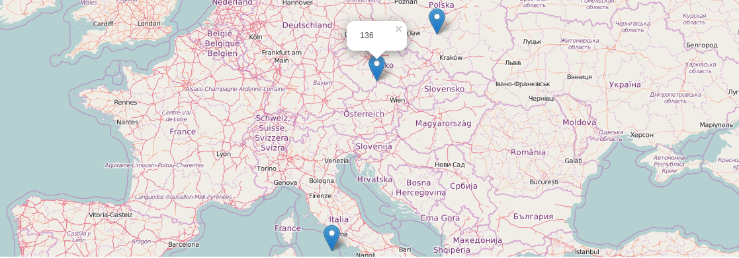

**### Proportion of buyers among the shops – Internal marketing strategy analysis**

select shop_id,count(visited_page)

from logfile

where visited_page LIKE '%udaje.php%'

group by shop_id

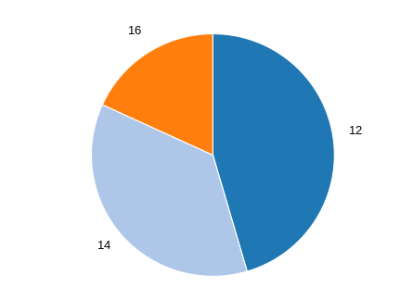

**### Identifying the peak traffic hours for buying**

SELECT hour(from_unixtime(time)) as hours, count(distinct(session_id)) as countOfSession FROM logfile

group by hour(from_unixtime(time))

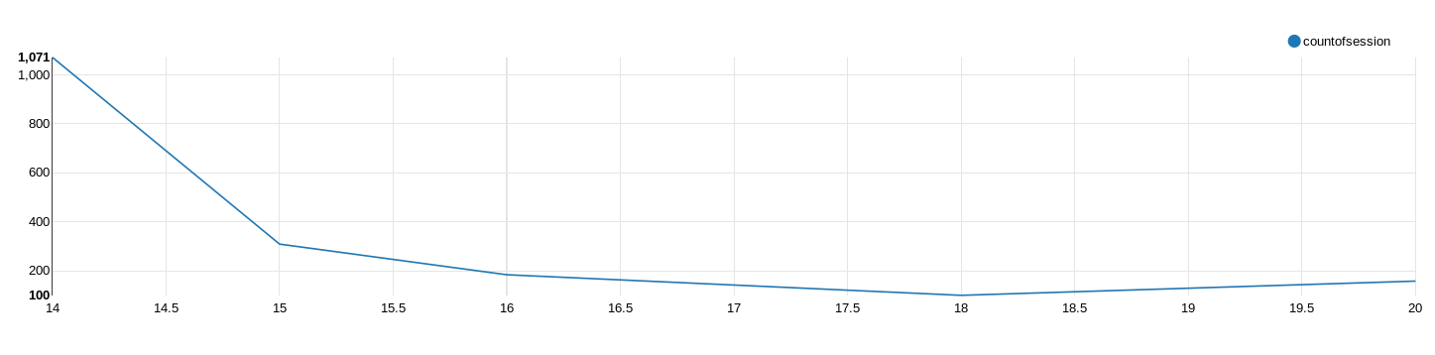

**### Identifying the peak traffic date (month-day-hour) for buying**

SELECT concat(month(from_unixtime(time)),'-',day(from_unixtime(time)),'-',hour(from_unixtime(time))) as date,count(distinct(session_id)) as countOfSession FROM logfile

group by concat(month(from_unixtime(time)),'-',day(from_unixtime(time)),'-',hour(from_unixtime(time)))

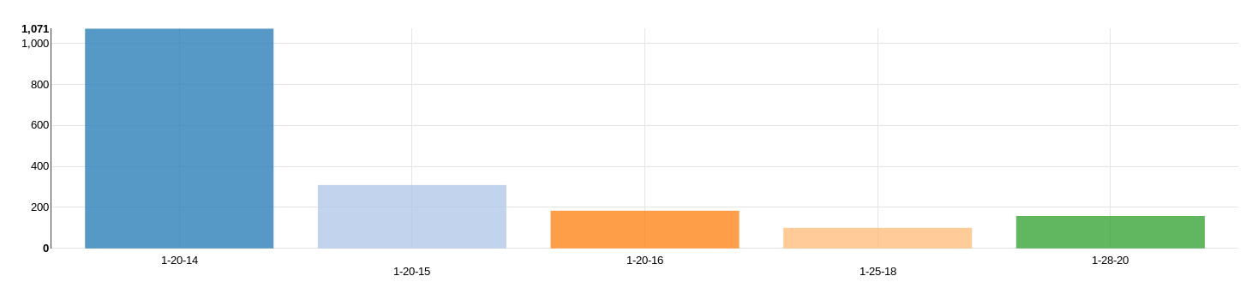

select count(visited_page LIKE '%udaje.php%') as noOfPurchases, ll.lati, ll.longi

from logfile l join ip_address i join lat_long ll

where visited_page LIKE '%udaje.php%'

and l.ip_address BETWEEN i.ip_start AND i.ip_end and i.country_id = ll.country_code

group by ll.lati, ll.longi

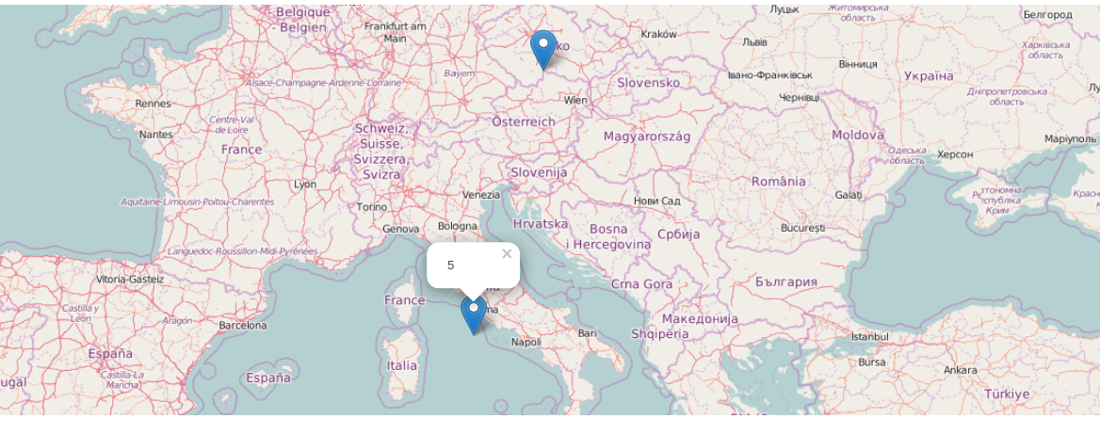

select country_id, count(*) from ip_address

group by country_id

select shop_id, count(distinct(session_id)) as count from logfile

group by shop_id

SELECT from_unixtime(time) as new_time, shop_id, ip_address, session_id, visited_page, referer

FROM logfile where shop_id = 14

select l.ip_address, i.country_id from logfile l join ip_address i

where l.ip_address BETWEEN i.ip_start AND i.ip_end limit 100

select day(from_unixtime(time)) as days, count(distinct(session_id)) as countOfSession FROM logfile

group by day(from_unixtime(time))

SELECT hour(from_unixtime(time)) as hours, count(distinct(session_id)) as countOfSession FROM logfile

group by hour(from_unixtime(time))

select countOfSession, days, hours from

(SELECT day(from_unixtime(time)) as days,

hour(from_unixtime(time)) as hours,

count(distinct(session_id)) as countOfSession

FROM logfile)

group by days, hours

select o.shop_id, o.name, l.session_id, l.visited_page from logfile l

join obchod o

on l.shop_id = o.shop_id

limit 50;

select shop_id, session_id, count(session_id) from logfile

group by shop_id, session_id having count(session_id)>50

# Additional SQL Commands

#### Overwriting from another table

insert overwrite table c_part partition (country) select * from c_ip;